Definition of Receipts

Even with the implementation of the electronic Concur Reimbursement System, Harvard must follow specific rules that comply with the IRS Accountable Plan to ensure reimbursements are not taxable to the recipient/reimbursee. One requirement is that a reimbursement request must be substantiated with receipts showing evidence of payment. Below are the minimum requirements for a receipt to be acceptable as proof of purchase for reimbursement. Credit card statements alone are not acceptable in lieu of receipt. Reimbursees and approvers are jointly responsible for ensuring duplicate receipts are not submitted for payment. In most cases, receipts equal to or greater than $75 are required.
Contact your school or unit to see if there are additional requirements and restrictions regarding reimbursement requests. See Responsibilities of Purchasers, Preparers and Approvers (ROPPA) and the Travel or Business Expense Reimbursements Policy for detailed restrictions.
Generally, Nonemployees must follow Harvard policies. Harvard business-related reimbursements are processed through the HCOM system as nonemployee reimbursements (NR). Expenses which are considered taxable (e.g., payments for services) should be processed as a payment request (PR).
Minimum Requirement(s): Below are minimal requirements to meet IRS Accountable Plan rules.
- Date of transaction
- Name of merchant
- Transaction details (what was purchased)
- The amount of purchase
- The form of payment used (credit card, cash, check)
- Indication that the amount was paid
- Handwritten receipts that do not contain the above information require a Missing Receipt Affidavit (MRA)
PLANE or TRAIN TICKETS: Supporting documentation for online booking or purchases must be a receipt and not an itinerary or booking reservation confirmation. An e-ticket email receipt normally includes all required information.
  - Passenger name
  - Issue date
  - E-ticket or ticket number with proof of payment
  - Total payment
  - Itinerary
  - Class of service (which should appear on an itinerary or ticket confirmation) First class is not an allowable expense.
  - Payment type
  - Boarding passes for each leg of a trip and a credit card statement meet receipt requirements.
HOTELS: Hotel folios are required, regardless of amount and must include:
  - Name and address of hotel
  - Guest name
  - Number of guests
  - Check in and out dates
  - Number of rooms and number of nights
  - Price per night
  - Total payment
  - Proof of payment (hotel folio showing zero balance, precheck out folio plus credit card statement showing full payment, or cancelled check)
  - Transaction date
MEALS: Meals with alcohol require special processes, see below.
  - Transaction date
  - Name of merchant

    - Itemized Receipt: The reimbursee often receives two receipts. One showing what was purchased and the second showing the payment method and tip. Both should be submitted. If an itemized receipt is not available then:

While not required on the receipt, the number and name(s) of the guests are required for reimbursement.
- If the meal(s) did not include alcohol, the reimbursee must attest that no alcohol was charged (on the receipt and in Concur).
- If the meal(s) did include alcohol and the reimbursee can attest in writing to the alcohol cost, than the alcohol portion with applicable tax and tip must be charged to object code 8450. No alcohol may be charged to a federal award.
- If alcohol was included and the reimbursee cannot attest to the alcohol cost, then no portion of the meal cost can be charged to a federal award. For all other funding, the invoice should be prorated with a percentage of the alcohol charged to object code 8450. Schools may set their own prorated amounts as long as they are consistent, usually between 20-35% for alcohol and the balance for the meal.

  - Proof of payment (credit card statement, receipt or cancelled check)

REGISTRATIONS:
  - Name of attendee
  - Name of conference
  - Amount paid
  - Conference dates
  - Proof of payment (receipt or cancelled check)

RENTAL CARS:
  - Name and address of vendor
  - Dates of rental
  - Transaction date
  - Itemization/transaction details
  - Amount paid
  - Proof of payment (receipt or cancelled check)

OTHER MISCELLANEOUS NON-TRAVEL PURCHASES:
  - Name and address of vendor
  - Date purchased
  - Itemization/Transaction details
  - Amount paid
  - Proof of payment (receipt or cancelled check)
  - Mobil phone reimbursement requests must comply with the University Staff Mobile Phone Policy. Out-of- pocket mobile phone or cellular service reimbursements require itemized bills showing calls related to Harvard business.
HANDWRITTEN RECEIPTS: Handwritten receipts which do not contain the below information require a Missing Receipt Affidavit (MRA)
- Date of transaction
- Name of merchant
- Transaction details (what was purchased)
- The amount of purchase
- The form of payment used (credit card, cash, check)
- Indication that the amount was paid
Missing Receipt Affidavits (MRAs): MRAs must be used as exceptions, not on a regular basis. When an original receipt has been lost or is otherwise not available, the reimbursee must attest that the expense was for legitimate Harvard business. Attestation may be through the creation of an electronic MRA in Concur or through the submission of a completed, signed MRA and proof of payment (credit card statement or copy of a cancelled check). Please contact your school or unit’s finance office for more information.

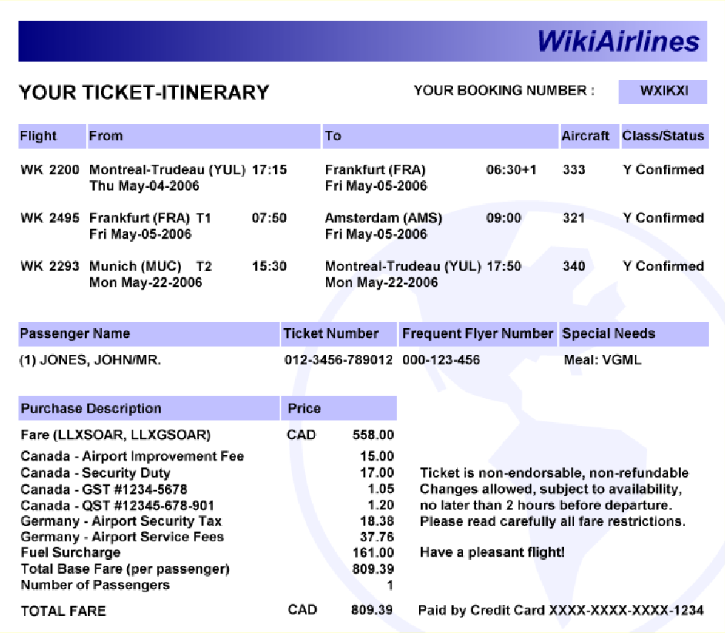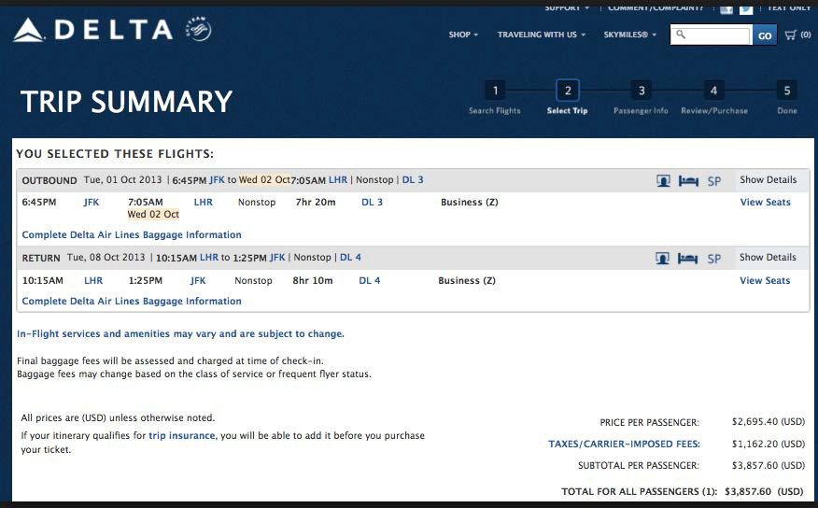EXAMPLE OF ETICKET VS CONFIRMATION
NOT A RECEIPT
Shows trip information, but does not show that the ticket has been paid for and issued.

PROPER RECEIPT
Shows travel information, ticket number, and proof of payment.

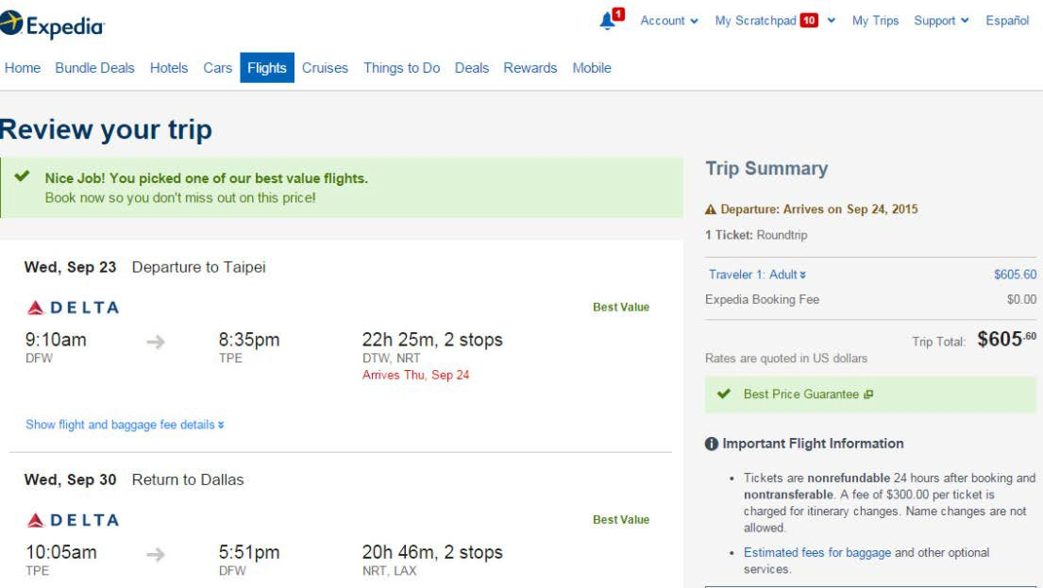
NOT A RECEIPT
Shows travel information, but does not show proof of payment and ticket number.

