Bambora Opt-In Instructions, effective November 8, 2021

Effective immediately, Concur has migrated to a new payment processor (Bambora) for “out of pocket” direct deposit payments. You must complete a one-time opt-in process to continue to receive your out-of-pocket reimbursements. The opt-in process authorizes Bambora to make deposits using your existing banking information in Concur.

- Banking details do not need to be re-entered
- Delegates cannot opt in on your behalf
- Cannot be done through the mobile app

You can choose either option below.

OPTION 1 (Recommended Approach):

- Login to Concur on the computer/browser
- Click on Profile
- Click Profile Settings
- Under Expense Settings at the left-hand side, select Bank Information
- Fill out the required fields (Note: If banking information already exists in your profile this will not be necessary)
- Check the tick box
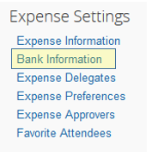
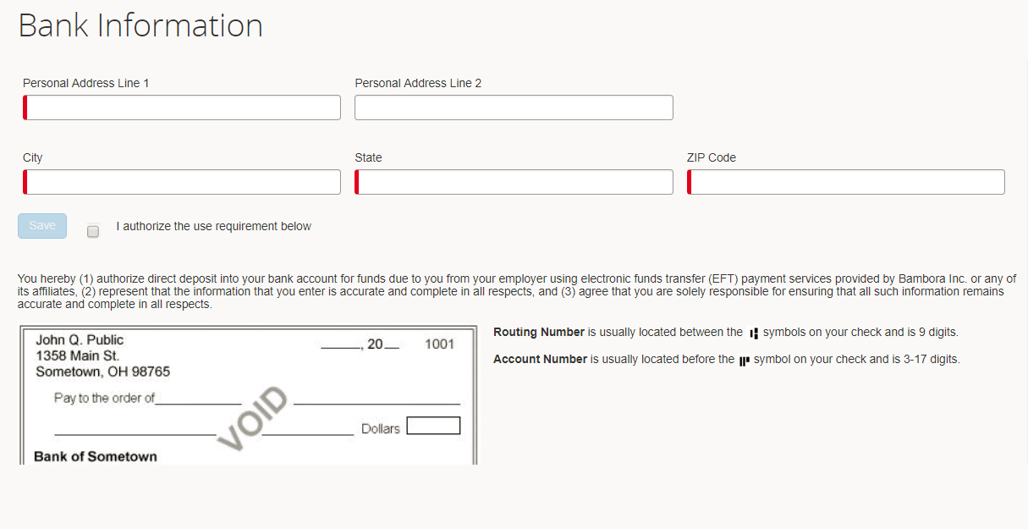
- Save

OPTION 2:
If you submit a new report after November 8th, you will be prompted to opt in directly from the submission screen. Once you’ve checked the box and submitted, you’re all set.

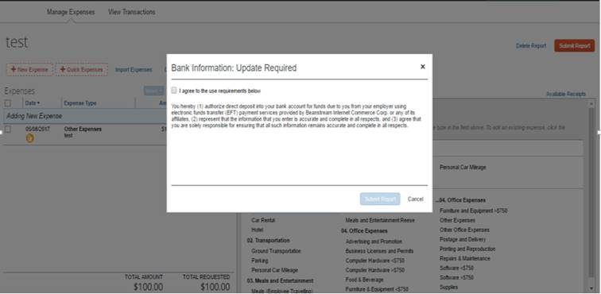
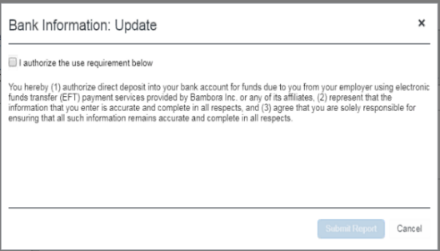
Note: This pop-up window will only show if you have out-of-pocket expense(s) in the report AND you did not do Option 1.

