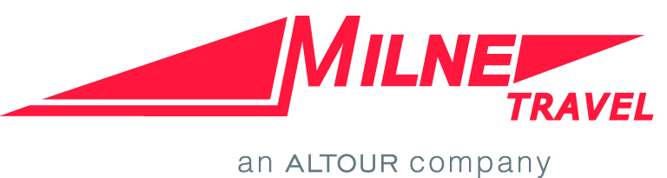

Benefits of Using Milne Travel:  - Milne Travel is a full-service customer-centric agency that provides in-depth travel planning and consulting services  - Knowledgeable, detail-oriented, experienced travel consultants familiar with Harvard travelers, policies and goals, who know the industry and can help you plan your next trip from start to finish  - Access to all of Harvard's negotiated discounts with the airline, hotel, car and rail vendors  - Milne Travel is an ALTOUR company, offering the following advantages to Harvard Travelers:  - Expertise in group and meeting travel | Contact Information:  - Designated Harvard counselors: 781-843-8952 or by direct dial to your personal counselor  - business.travel@milnetravel.com or by direct email to your personal travel counselor  To register a Meeting:  - Contact Cindy Pea  - 207-482-0985  - cindy.pea@milnetravel.com  After Hours/Emergency Assistance:  Check your itinerary, or call 888-876-4213  (812-206-5240 outside the U.S.)  Access code A- O(scar) 2 3
Payment Options:  - Harvard T & E Card  - Personal credit card and submit expense for reimbursement  - Billing account for your department | Fees: Click Here

